## **NATIONAL UNIVERSITY OF MODERN LANGUAGES, ISLAMABAD**

## NUML logo, Vector Logo of NUML brand free download (eps, ai, png, cdr ...

**Web Engineering - Lab**

**Lab # 3**

**Submitted By**

**Umer Hassan Khan**

**SP21020**

**Submitted To**

**Ma’am Nabeela Bibi**

**Date: 12/10/2023**

**Task # 01**

**Using table tag, Create a web page CV with your skills. Give it a name About me.html**

<!DOCTYPE html>

<html>

<head>

    <title>About Me</title>

</head>

<body>

<br>

<h1 style="text-align: center;">About Me</h1>

<table style="width:30%; text-align: center;">

    <tr>

        <td rowspan="3";>

<img src="https://th.bing.com/th/id/OIP.1kThRhIDRQchFF8XMJ-JbwHaEK?w=302&h=180&c=7&r=0&o=5&pid=1.7" width="100px"></td>

        <td>Name:</td>

        <td>Babar Azam</td>

    </tr>

        <tr>

        <td>Date of Birth:</td>

        <td>25-08-1995</td>

    </tr>

        <tr>

        <td>Gender:</td>

        <td>Male</td>

    </tr>

</table>

<hr>

<br>

<h2>Education Background</h2>

<table style="width:100%; text-align: center;">

<tr>

<th>Sr. No.</th>

<th>Degree</th>

<th>Institute</th>

<th>City</th>

<th>CGPA/Grade</th>

</tr>

<tr>

<td>1.</td>

<td>BS Software Engineering</td>

<td>NUML</td>

<td>Islamabad</td>

<td>3.45</td>

</tr>

<tr>

<td>2.</td>

<td>Higher Secondary School Certificate</td>

<td>Punjab College of Information Technology</td>

<td>Islamabad</td>

<td>A</td>

</tr>

<tr>

<td>3.</td>

<td>Secondary School Certificate</td>

<td>Public School</td>

<td>Lahore</td>

<td>A+</td>

</tr>

</table>

<br>

<a href="https://www.google.com">Return to Home Screen</a>

</body>

</html>

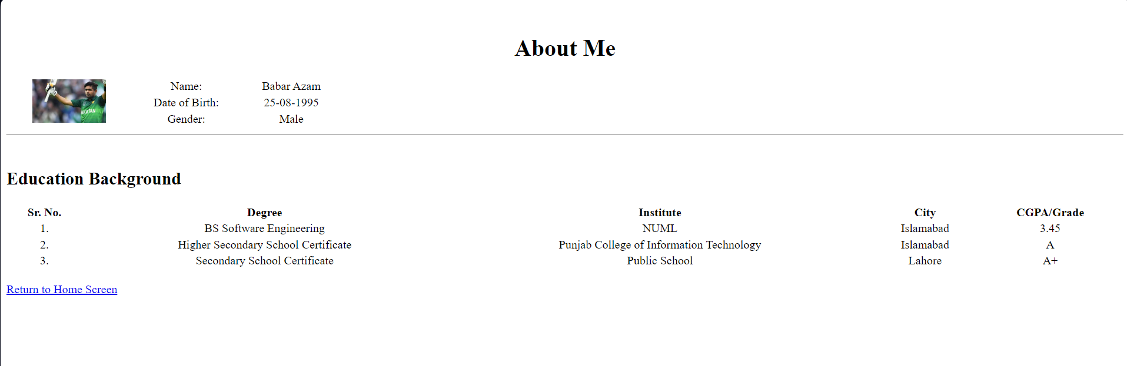

**Task # 02**

**Create a web page containing description list , table styling, rowspan ,column span and column group**

<!DOCTYPE html>

<html>

<head>

    <title>HTML Tables</title>

</head>

<body>

    <table style="width:40%; text-align: center; background-color: rgb(208, 118, 118);">

        <colgroup>

            <col span="3" style="background-color:#7ce3a7">

        </colgroup>

        <tr>

        <th style="border: 2px solid;">Firstname</th>

        <th style="border: 2px solid;">Lastname</th>

        <th style="border: 2px solid;">Age</th>

        </tr>

        <tr>

        <td style="border: 2px solid; padding: 20px;" colspan="2" >Jill</td>

        <td style="border: 2px solid; padding: 20px;" rowspan="2" >Smith</td>

        <td style="border: 2px solid; padding: 20px;">50</td>

        </tr>

        <tr>

        <td style="border: 2px solid; padding: 20px;" >Eve</td>

        <td style="border: 2px solid; padding: 20px;" >Jackson</td>

        <td style="border: 2px solid; padding: 20px;">94</td>

        </tr>

        </table>

        <hr><hr>

</body>

</html>

